**Assignment 2:**

**Switch case:**

import java.util.Scanner;

public class switchprogram {

public static void main(String[] args) {

System.*out*.println("Enter the month and year to find no. of days in the month:");

Scanner s=new Scanner(System.*in*);

int month=s.nextInt();

int year=s.nextInt();

int leap_year=0;

if(year%4==0) {

leap_year = 29;

}

else {

leap_year = 28;

}

switch(month)

{

case 1:

case 3:

case 5:

case 7:

case 8:

case 10:

case 12: System.*out*.println(31 +"Days");

break;

case 2: System.*out*.println(leap_year+" Days");

break;

case 4:

case 6:

case 9:

case 11:

System.*out*.println(30 +"Days");

break;

default: System.*out*.println("Try Again!");

break;

}

}

}

**Output:**

**Case 1:**

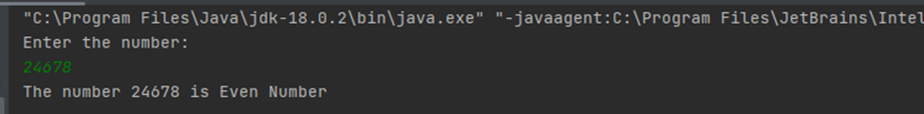

**Case2:**

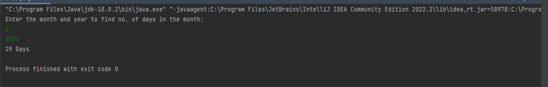

**Case 3:**

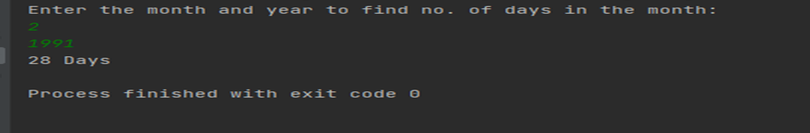

**2.TO PRINT EVEN OR ODD NUMBER**

import java.util.Scanner;

public class print() {

public static void main(String[] args) {

System.*out*.print("Enter the number:");

Scanner s=new Scanner(System.*in*);

int n=s.nextInt();

if (n%2==0)

{

System.*out*.println("The number "+n+" is Even Number");

}

else {

System.*out*.print("The number "+n+" is odd nnumber");

}

}

}

**OUTPUT:**



